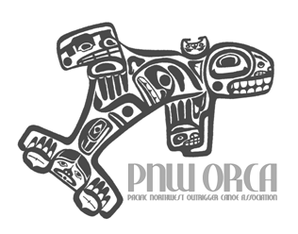
PNW-ORCA 2017 Summer Race Schedule
Pacific Northwest Outrigger Racing Canoe Association

Date | Day | Race / Host | Race Site
April 22 | Saturday | Rusty Iron Distance Race  Pacific Outrigger Canoe Club | Frenchman’s Bar  Vancouver, WA
May 6 | Saturday | Race Around the Island  Columbia River Outrigger Canoe Club | Fairway, OR
May 13 | Saturday | Manu K. Baker Sprint Regatta  Kikaha O ke Kai | Spanaway Lake  Spanaway, WA
May 27 | Saturday | Na Po’e O ke Kai Sprint Regatta  Hui Wa’a O Wakinikona | Green Lake  Seattle, WA
June 10 | Saturday | Hui Wa’a O Puget Sound Sprint Regatta  Hui Wa’a O Puget Sound | Silver Lake  Everett, WA
June 17 | Saturday | Rooster Rock  Mountain Home Canoe Club | Rooster Rock State Park  Corbett, OR
June 24 | Saturday | Hui Heihei Wa’a Sprint Regatta  Hui Heihei Wa’a | Waterfront Park  Silverdale, WA
July 15 – 16 | Saturday & Sunday | Gorge Distance Race & OC1/OC2 Race  Waterwalker- JD Davies | County Fairgrounds  Stevenson, WA
July 29 | Saturday | Da Grind  Seattle Outrigger Canoe Club
Aug 12 | Saturday | Bellingham Bay Iron  Bellingham Bay Outrigger Paddlers | Boulevard Park  Bellingham, WA
Aug 19 | Saturday | PNW Challenge  Kikaha O ke Kai/Sand Point Outrigger | Seattle, WA
Oct 21 | Saturday | Ruston Relay  To be determined | Tacoma, WA

